Chemistry 20

Lesson 1 – Alchemy becomes chemistry

**Chemistry** is primarily a study of **matter** and **changes in matter**. As an introduction to Chemistry 20, let’s briefly look at how people have historically understood matter.

# Alchemy

FIRE

WATER

AIR

EARTH

hot

dry

cold

moist

For thousands of years, philosophers of nature held to a theory of matter put forward by Aristotle in the 6th century BCE. All matter was composed of a combination of four **elements** (fire, air, water, earth) and a number of **principles** (dry, hot, moist, cold). By using these principles and elements in various combinations, the varying properties of different compounds could be “explained.” Alchemy was the study of nature’s elements and principles. Alchemy was a mixture of philosophy, astrology, mysticism, magic, science and many other subjects. It was an attempt to unify one’s knowledge through a search for the **philosopher’s****stone** (no, not Harry Potter’s stone). The philosopher’s stone was believed to be the pure substance underlying all of matter, all thought, and all creation which could transmute anything into gold. Gold was symbolic of the material form of God – permanent, incorruptible and pure. During the Middle Ages in Europe, the science of alchemy flourished. Many scientists, including Sir Isaac Newton, were quite involved in the study of alchemy.

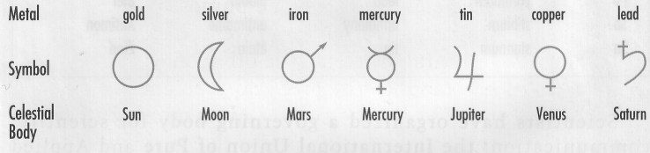Since ancient times, people have known of seven naturally occurring metallic elements. And long before the invention of the telescope, they were also aware of seven celestial bodies: the sun, the moon, and the five "wandering stars" that we now know as planets. In their writings, the same symbols used to represent the seven elements were used to represent the seven known celestial bodies. Magic, observation, and experimentation all played important roles in alchemy. Although they failed in their quest, they developed many experimental procedures and discovered new elements and compounds.

Alchemy gradually became modern science when people chose to limit themselves to theories and hypotheses that could be verified through empirical, repeatable experiment. In other words, the hallmark of science is that ideas can be verified or falsified based on empirical measurements. Further, such measurements must be repeatable by other investigators who conduct the same experiment. Questions or philosophical ideas about the nature of God, for example, were excluded from the scientific enterprise and were pursued through other means.

By the early 1800s, scientists had discovered many new elements, and the complexity of their symbols led to problems in communication. This prompted an English chemist and former schoolteacher, John Dalton (1766-1844), to devise simpler symbols for each element. A sample of his symbols are given on the right. To see more of Dalton’s symbols for elements and compounds visit <http://www.3rd1000.com/alchemy/dalton/dalton_s.htm>.

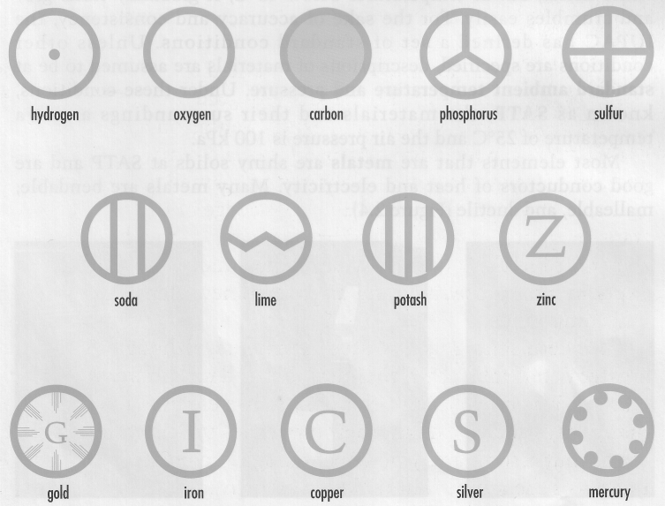

In 1814, Swedish chemist Jons Jacob Berzelius (1779-1848) suggested using **letters as symbols for elements**. In this system, which is still used today, the symbol for each element consists of either a single capital letter or a capital letter followed by a lower case letter. Because Latin was the common language of communication among educated Europeans in Berzelius' day, many of the symbols were derived from the Latin names for the elements. Today, although the names of elements are different in different languages, the same symbols are used in all languages. Scientists throughout the world depend on this language of symbols, which is international, precise, logical, and simple.

|  |  |  |  |  |
| --- | --- | --- | --- | --- |
| **Symbols and names of a few Elements** | | | | |
| **Symbol** | **Latin** | **English** | **French** | **German** |
| Ag | argentum | silver | argent | Silber |
| Au | aurum | gold | or | Gold |
| Cu | cuprum | copper | cuivre | Kupfer |
| Fe | ferrum | iron | fer | Eisen |
| Hg | hydrargyrum | mercury | mercure | Quecksilber |
| K | kalium | potassium | potassium | Kalium |
| Na | natrium | sodium | sodium | Natrium |
| Pb | plumbum | lead | plomb | Blei |
| Sb | stibium | antimony | antimoine | Antimon |
| Sn | stannum | tin | etain | Zinn |

Scientists have organized a governing body for scientific communication: the **International Union of Pure and Applied Chemistry** (IUPAC) specifies rules for chemical names and symbols.

# Dalton and the postulates of chemical philosophy

John Dalton is known as the father of chemistry. He was colour blind and therefore had great difficulty working in the laboratory. His accomplishments rest on his ingenious interpretation of the work of previous experimenters like Francis Bacon, Benjamin Franklin, William Gilbert, Charles Coulomb, Antoine Lavoisier, and many others. Before the time of John Dalton, chemistry did not exist. All research was classified as alchemy, and most of the relevant information in the field existed because of the commitment of alchemists into turning base metals (lead, antimony, etc.) into gold. Many alchemists went to their graves as a direct result of heavy metal poisoning due to their experiments.

Dalton synthesized all previous research in the field of alchemy into**five basic postulates of chemical philosophy** that gave a starting point for all further research. He published the five postulates in 1808 and chemistry began. As we shall see, Dalton’s postulates are still the basic principles that we use to this day.

**The Five Postulates of Chemical Philosophy**

1. Matter is composed of indivisible atoms.
2. Each element consists of a characteristic kind of identical atom.
3. Atoms are unchangeable.
4. When different elements combine and form a compound, the smallest possible portion of the compound (molecule) is a group containing a definite, whole number of atoms of each element.
5. In chemical reactions, atoms are neither created nor destroyed, but only rearranged.

In general, Dalton believed that all elements were composed of extremely tiny, indivisible and indestructible atoms (i.e. solid spheres) and that all substances were composed of various combinations of these atoms. He also believed that atoms of different elements were different in size and mass. In keeping with the quantitative spirit of the times, he tried to determine numerical values for their **relative masses**. We refer to Dalton’s relative mass as **atomic mass** today.

# The periodic nature of the elements

In the year 1800, all previous work by all the alchemists over centuries had identified 31 different elements. John Dalton’s new field of chemistry encouraged the discovery of many new elements. By 1860, the number of known elements totalled 60. The sheer number of elements, plus the almost constant discovery of new elements, spurred interest in the organization of the elements into categories.

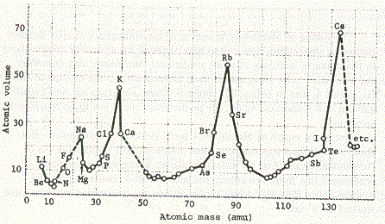In 1865, J. Newlands produced the first list of the known elements. He ranked all the known elements according to increasing atomic mass. When this was done, a surprising observation became evident. For example, sodium, potassium, lithium, rubidium, and cesium are all soft, silvery-white metals. They are highly reactive elements, and they form similar compounds with chlorine. There is a strong "family" resemblance among them. The elements that follow these five in Newlands' arrangement−beryllium, magnesium, calcium, strontium, and barium−also exhibit a strong family resemblance. Newlands noticed that various physical and chemical properties of these and other families were repeated periodically in the sequence of elements. He stated this observation as a periodic law: **When elements are arranged in order of increasing atomic mass, chemical and physical properties form patterns that repeat at regular intervals**.

Julius Meyer (1830-1895) examined some physical properties of the elements and decided to plot relative atomic size against increasing atomic mass. His graph produced a series of peaks and valleys. The peaks corresponded to members of the alkali metals. In other words, the first peak was lithium the second peak was sodium the third peak was potassium, and so on. The valleys corresponded to the halogens. In the first valley was fluorine, the second valley was chlorine, the third valley was bromine, and so on. Meyer concluded that the properties of the elements might be a **periodic** (re-occurring) function of their atomic mass. Meyer published his research in early 1869 and he received the Copley medal (equivalent to the Nobel prize today) for his work from the Royal Society of London in 1882.

# Dmitri Mendeleev

Dmitri Ivanovich Mendeleev (1834 - 1907) was born in Siberia, the youngest of 17 children.

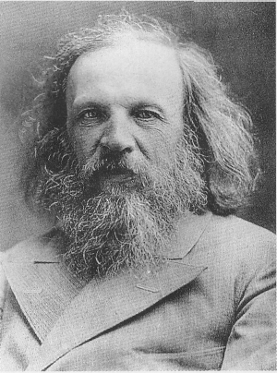Mendeleev was unable to gain admission into the University of Moscow, but he was accepted into the University of St. Petersburg. In 1861, he received a doctorate in Chemistry for a thesis on the combination of alcohol with water. After becoming a chemistry professor, he explored a wide range of interests, including natural resources such as coal and oil, meteorology, and hot air balloons. His work demanded tremendous patience and an extremely methodical approach. Imagine collecting all available information on all the elements, and then searching for patterns that no one else had noticed. In 1869, Mendeleev began to prepare a table of the elements. Like Meyer, he recognized the importance of the recurring chemical and physical properties of the chemical families. So he began to set up a table that would increase in atomic mass while still accounting for the periodic families of elements. He wrote, “I saw in a dream a table where all the elements fell into place as required. Awakening, I immediately wrote it down on a piece of paper. Only in one place did a correction need to be made.” In Mendeleev’s table, atomic mass increases horizontally but elements are grouped vertically according to chemical and physical properties (or chemical families). His 1869 version shows the vertical and horizontal combinations.

|  |  |  |  |  |  |  |  |  |  |  |  |  |  |  |  |  |  |  |  |  |  |
| --- | --- | --- | --- | --- | --- | --- | --- | --- | --- | --- | --- | --- | --- | --- | --- | --- | --- | --- | --- | --- | --- |
| 1 |  |  |  |  |  |  | H | |  |  |  |  |  |  | Li |  |  |  |  |  |  |
| 2 |  |  |  |  |  |  |  | | Be | B | C | N | O | F | Na |  |  |  |  |  |  |
| 3 |  |  |  |  |  |  |  | | Mg | Al | Si | P | S | Cl | K | Ca | - | Er? | Y? | In? |  |
| 4 | Ti | V | Cr | Mn | Fe | Ni Co Cu | | | Zn | - | - | As | Se | Br | Rb | Sr | Ce | La | Di | Tb |  |
| 5 | Zr | Nb | Mo | Rh | Ru | Pd | Ag | | Cd | U | Sn | Sb | Te | I | Cs | Ba |  |  |  |  |  |
| 6 | - | Ta | W | Pt | Ir | Os | | Hg | - | Au | - | Bi | - | - | Tl | Pb |  |  |  |  |  |

By 1871, Mendeleev had designed a table that looks very similar to the periodic table we use today. The transition elements do not appear until the fourth horizontal row (Ti through Zn). This version of the table was actively used until 1914.

|  |  |  |  |  |  |  |  |  |  |  |  |  |  |  |  |  |
| --- | --- | --- | --- | --- | --- | --- | --- | --- | --- | --- | --- | --- | --- | --- | --- | --- |
| H |  |  |  |  |  |  |  |  |  |  |  |  |  |  |  |  |
| Li | Be |  |  |  |  |  |  |  |  |  |  | B | C | N | O | F |
| Na | Mg |  |  |  |  |  |  |  |  |  |  | Al | Si | P | S | Cl |
| K | Ca | - | Ti | V | Cr | Mn | Fe | Co | Ni | Cu | Zn | - | - | As | Se | Br |
| Rb | Sr | Y? | Zr | Nb | Mo | - | Ru | Rh | Pd | Ag | Cd | In | Sn | Sb | Te | I |
| Cs | Ba | Di? | Ce | - | - | - | - | - | - | - | - | - | - | - | - | - |
| - | - | Er | La? | Ta? | W | - | Os | Ir | Pt | Au | Hg | Tl | Pb | Bi | - | - |
| - | - | - | Th | - | U | - | - | - | - | - | - | - | - | - | - | - |
|  |  |  |  |  |  |  |  |  |  |  |  |  |  |  |  |  |

Mendeleev’s greatest claim to fame came from the predictions he made about the blanks on his periodic table. In 1871, Mendeleev made three predictions concerning three blanks on his table. These elements were all discovered by 1886 – note Mendeleev’s accuracy.

**Properties of the Elements Scandium, Gallium, and Germanium**

|  |  |  |
| --- | --- | --- |
| **Property** | **Mendeleev’s Predictions in 1871** | **Observed Properties** |
|  |  |  |
|  | **Scandium (Discovered in 1877)** |  |
| Molar Mass | 44 g | 43.7 g |
| Oxide formula | M2O3 | Sc2O3 |
| Density of oxide | 3.5 g/ ml | 3.86 g/ml |
| Solubility of oxide | Dissolves in acids | Dissolves in acids |
|  |  |  |
|  | **Gallium (Discovered in 1875)** |  |
| Molar mass | 68 g | 69.4 g |
| Density of metal | 6.0 g/ml | 5.96 g/ml |
| Melting temperature | Low | 30º C |
| Oxide formula | M2O3 | Ga2O3 |
| Solubility of oxide | Dissolves in ammonia solution | Dissolves in ammonia solution |
|  |  |  |
|  | **Germanium (Discovered in 1886)** |  |
| Molar mass | 72 g | 71.9 |
| Density of metal | 5.5 g/ml | 5.47 g/ml |
| Color of metal | Dark gray | Grayish white |
| Melting temperature of metal | High | 900º |
| Oxide formula | MO2 | GeO2 |
| Density of oxide | 4.7 g/ml | 4.70 g/ml |

Mendeleev’s periodic table explained all known items and the table was accurate enough to make predictions that proved to be correct. Mendeleev was rewarded with the Davy Medal (Royal Society of London) in 1882, the Faraday Medal (English Chemical Society) in 1884 and the Copley Medal (Royal Society of London) in 1905.

There were two mistakes on the periodic table produced by Mendeleev. The first one concerned an element that Mendeleev didn’t even know about. Argon has a mass of 39.95 and potassium has a mass of 39.10. This is not increasing by atomic mass, but we can forgive Mendeleev for this error. Mendeleev did know about the second error. Tellurium has a mass of 127.60 and iodine has a mass of 126.90. Once again mass is not increasing. Mendeleev was forced to place these two elements according to their chemical and physical properties. Mendeleev believed so strongly in the chemical families (vertical columns) that he believed that the mass of tellurium must be wrong. Perhaps if he had known about argon, he would have revised his model.

Henry Moseley (1887-1915) would provide the correction in 1908. While doing x-ray diffraction through crystals he discovered that the reason tellurium comes before iodine is that tellurium has 52 protons in its nucleus and iodine has 53 protons in its nucleus. Argon has 18 protons, in its nucleus and potassium has 19 protons in its nucleus. Moseley proposed that the table was correct in its vertical columns according to chemical families and the horizontal rows are actually increasing by the number of protons in the nucleus. We call that property the **atomic number**. As a result, Mendeleev’s basic idea remains the same, but we now have atomic number as the controlling factor horizontally. Young Moseley would die in the trenches of World War I at the age of 28. As a result of Moseley’s early death, a law was passed in the English Parliament banning active service for scientists.

For those who are interested in knowing when different elements were discovered, check out the following website: <http://www.dreamwv.com/primer/page/s_pertab.html>

# The Modern Periodic Table

The figure shows the modern periodic table. In this table, every element is in sequence, but the width of the table makes it difficult to print on a single page.

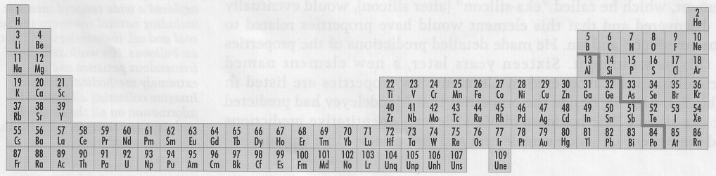

Therefore the periodic table is usually printed in the form shown below with two separate rows at the bottom (the lanthanide series and the actinide series).

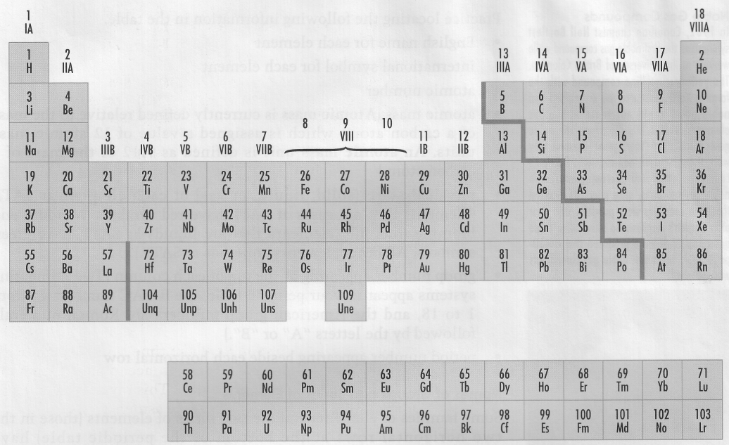

1

2

4

5

3

7

6

Note the important features of this table.

• A **family** or **group** of elements has similar chemical properties and includes the elements in a vertical column in the main part of the table.

• A **period** is a horizontal row of elements whose properties gradually change from metallic to nonmetallic from left to right along the row.

Compare the periodic table above with the one that is in your data booklet. Periodic tables usually include each element's symbol, atomic number, and atomic mass, along with other information that varies from table to table. You may want to practice locating the following information in the table.

• English name for each element

• international symbol for each element

• atomic number

• atomic mass (**Atomic mass** is currently defined relative to the mass of a carbon atom, which is assigned a value of 12 atomic mass units. An atomic mass unit is defined as 1/12 of the mass of a carbon atom.)

• physical state (solid, liquid, or gas) of each element at **SATP** (For the sake of accuracy and consistency, the IUPAC has defined a set of **standard conditions**. Unless other conditions are specified, descriptions of materials are assumed to be at **standard ambient temperature and pressure** (this is a fancy way of saying “room temperature and pressure”). Under these conditions, known as **SATP**, the materials and their surroundings are at a temperature of 25°C and the air pressure is 100 kPa.)

• group number appearing at the top of each column (Two numbering systems exist. The IUPAC numbers go from 1 to 18. These are the numbers that are used in the periodic table found in the Chemistry Data Booklet. A second numbering system, the American group numbers, are Roman numerals followed by the letters "A" or "B". See the periodic table above.)

# Metals and Nonmetals

**Metals** are located to the left of the "staircase line" in the periodic table, and **nonmetals** to the right. Most metals are shiny solids at SATP and are good conductors of heat and electricity. Many metals are bendable, malleable, and ductile. However, different conditions can dramatically change an element’s properties. For example, ordinarily tin is a white metal, but at temperatures below 13°C, it gradually turns grey and crumbles easily. Elements that are nonmetals may be solids, liquids, or gases at SATP. Whatever their state, nonmetallic elements are poor conductors of heat and electricity. When in solid form, nonmetallic elements are brittle and lack the lustre of metals.

Some elements exhibit metallic and nonmetallic properties. and are classified as **metalloids** or **semi-metals**. They are found on both sides of the staircase that separates metals and nonmetals. The metalloids are boron, silicon, germanium, arsenic, antimony, tellurium and polonium.

# Special names of groups and periods of elements

Some families of elements and the two series of elements (those in the two horizontal rows at the bottom of the periodic table) have traditional names that are commonly used in scientific communication. It is important to learn these names.

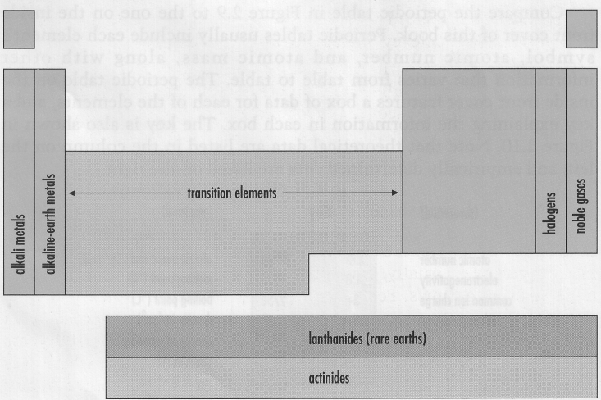

• The **alkali metals** are the family of elements in Group 1. They have similar physical properties: silver colour, bright lustre, good electrical conductors, soft and malleable, and low melting point. They react violently with water to form basic solutions. The most reactive alkali metals are cesium and francium.

• The **alkaline-earth metals** are the family of elements in Group 2. They are light, reactive metals that form oxide coatings when exposed to air. These oxide coatings seal surfaces and prevent further reaction.

• The **halogens** are the elements in Group 17. They are all extremely reactive, with fluorine being the most reactive. Halogens combine readily with metals to form **salts**. The common usage for salt refers to one particular kind of salt, namely table salt or sodium chloride. But in chemistry, **salt** is a general term for any ionic compound.

• The **noble gases** are the elements in Group 18. They are special because of their extremely low chemical reactivity at SATP. The noble gases are of special empirical and theoretical interest to chemists.

• The **representative elements** are the elements in Groups 1, 2, and 13 to 18. Of all the elements, the representative elements best follow the periodic law. For the sake of simplicity, the laws and theories presented in introductory chemistry courses are often restricted to these elements.

• The **transition elements** are the elements in Groups 3 to 12 (originally labelled the "B" groups). These elements exhibit a wide range of chemical and physical properties.

The bottom two rows in the periodic table also have common names. The **lanthanides** (rare-earth elements) are the elements with atomic numbers 58 to 71. The **actinides** are the elements with atomic numbers 90 to 103. The synthetic (not naturally occurring) elements that have atomic numbers of 93 or greater are referred to as **transuranic** elements.

# Assignment

**Part A**: Fill in the blanks with the appropriate word or phrase:

1. An element is usually represented by a _____________.
2. The modern periodic table was developed by Dmitri _______________.
3. Vertical columns in the periodic table are called ______________. Horizontal rows are called ________________.
4. Common family names for the elements in group 1, 2, 17, and 18 are, respectively, ____________, ____________, ____________, and ____________.
5. The elements in groups 3 to 12 are referred to as ______________.
6. The most reactive metal is _____________ and the most reactive non-metal is _______________.
7. _______________ is an example of a metalloid.
8. SATP stands for ____________ ____________ _____________ ___________.
9. In general, atomic mass increases from left to right and top to bottom on the periodic table. Not including the actinides and lanthanides, there are two places where the trend is reversed. These are: ________________________________________________________________

**Part B**: Write the name of the element which best matches the description.

1. The element that has atomic number 26. __________

2. The noble gas in period four. __________

3. The atom in period two that forms an ion with a 3− charge. __________

4. The non-metal that is a liquid at SATP. __________

5. The element whose atoms contain 56 protons. __________

6. The alkali metal in period four. __________

7. The alkaline earth metal in period five. __________

8. The first of the synthetic (man-made) elements. __________

9. The largest naturally occurring element. __________

**Part C**: Use your periodic table to answer the following questions.

1. Complete the following paragraph with the correct terms.

The element called ___________ has an atomic number of 24. Its symbol is _____ . When an atom of this element has a ___________ ___________ of 52, the atom contains ____ protons and ____ neutrons. The most common ion charge of this element is _____.

2. Identify each element.

(a) the element in group 5 and period 5 ___________

(b) only halogen that is a liquid at room temperature and pressure ___________

(c) alkali metal with the most massive atoms ___________

(d) synthetic element in period 5 ___________

(e) nonmetal group 16 and period 4 ___________

(f) alkaline earth element with the least massive atoms ___________

(g) noble gas that has atoms with 54 protons ___________